 | American journal of pure and applied physics  australiansciencejournals.com/ajpap  E-ISSN: 2688-0989  VOL 05 ISSUE 06 2024

High-Resolution Spectroscopy of Quantum Materials
Dr. John Smith,
Department of Physics, University of Cambridge, UK,
Email: john.smith@cam.ac.uk
Abstract:
High-resolution spectroscopy is a powerful technique that has been instrumental in the study of quantum materials, allowing for detailed insights into their electronic, optical, and magnetic properties. These materials, including topological insulators, superconductors, and quantum dots, exhibit unique quantum phenomena that are often challenging to probe with traditional methods. By employing techniques such as angle-resolved photoemission spectroscopy (ARPES), Raman spectroscopy, and neutron scattering, researchers can explore the intricate interactions between particles within these materials. This paper reviews the current advancements in high-resolution spectroscopy, highlighting key techniques, applications, and the future directions of research in quantum materials.
Keywords: high-resolution spectroscopy, quantum materials, ARPES, topological insulators, superconductivity, Raman spectroscopy, quantum dots, neutron scattering
Introduction:
Quantum materials, which display novel physical phenomena due to quantum mechanical effects, have become a cornerstone of condensed matter physics. Understanding these materials requires precise measurement techniques capable of resolving fine details in their electronic, magnetic, and structural properties. High-resolution spectroscopy plays a pivotal role in this area, providing a window into the microscopic dynamics of quantum materials. By using advanced spectroscopic methods, it is possible to observe subtle quantum effects such as band structure formation, spin-orbit coupling, and quantum coherence. This paper provides an overview of the key high-resolution spectroscopy techniques and their application in the study of quantum materials.
1.Principles of High-Resolution Spectroscopy:
High-resolution spectroscopy is essential for understanding the complex electronic, magnetic, and structural properties of quantum materials. The resolution of a spectroscopic technique determines the level of detail it can provide about the material's behavior at the microscopic scale. In quantum materials, where fine interactions and subtle quantum phenomena occur, achieving high resolution is crucial for unraveling intricate details that define their unique properties.
Spectroscopic Methods Employed in Quantum Materials:
Several spectroscopic techniques are commonly used to study quantum materials. These methods vary in their principles and the type of information they can provide:
Angle-Resolved Photoemission Spectroscopy (ARPES):
ARPES is one of the most powerful techniques for probing the electronic structure of quantum materials. By measuring the kinetic energy and momentum of photoemitted electrons, ARPES provides direct insights into the band structure and the dynamics of electrons in solids. This technique is particularly useful for understanding topological insulators, superconductors, and graphene.
Raman Spectroscopy:
Raman spectroscopy is based on inelastic scattering of photons, providing information about vibrational modes, phonon energies, and electron-phonon interactions in materials. In quantum materials, Raman spectroscopy helps probe lattice dynamics, electron-phonon coupling, and can be applied to study quantum dots, nanomaterials, and superconductors.
Neutron Scattering:
Neutron scattering is used to investigate the magnetic and structural properties of quantum materials. Neutrons are particularly sensitive to the positions of atoms in a crystal lattice and can probe low-energy excitations, making them ideal for studying quantum spin systems and correlated electron systems.
X-ray and Synchrotron Radiation Techniques:
X-ray diffraction (XRD) and X-ray photoelectron spectroscopy (XPS) are widely used to analyze the structural, chemical, and electronic properties of quantum materials. Synchrotron radiation, in particular, provides high-energy X-rays that can probe atomic-level interactions in materials under varying conditions.
Electron Energy Loss Spectroscopy (EELS):
EELS is an electron microscopy technique that measures energy loss from electrons as they pass through a material. This loss is indicative of the material's electron density and bonding characteristics, and it is used to study the local electronic structure in quantum materials.
Significance of Resolution in Spectroscopy:
In high-resolution spectroscopy, the ability to resolve fine details in energy, momentum, or frequency is essential. The resolution defines the precision with which we can distinguish between closely spaced energy levels, allowing researchers to observe small but significant effects that characterize quantum materials, such as:
Band Structure and Quasiparticles: High-resolution techniques can reveal the detailed energy bands of a material and identify quasiparticles such as fermions, bosons, and excitons. These quasiparticles play a key role in the physical properties of quantum materials, including their superconductivity and magnetism.
Electron-Phonon Interactions: The resolution of spectroscopic methods enables the observation of interactions between electrons and phonons. These interactions are fundamental to understanding phenomena such as superconductivity, where the pairing of electrons via phonon exchange can lead to superconducting states.
Quantum Coherence and Entanglement: In quantum materials, quantum coherence is a crucial property for phenomena such as quantum computing and entanglement-based technologies. High-resolution spectroscopy allows for the detection of coherence effects, providing information on quantum phase transitions, the role of disorder, and the persistence of quantum entanglement at macroscopic scales.
By obtaining precise measurements of energy and momentum, high-resolution spectroscopy helps researchers investigate the fine details of quantum materials that are often inaccessible with lower-resolution methods. These insights contribute to a deeper understanding of the behavior and potential applications of these materials in next-generation technologies.
2.Techniques for High-Resolution Spectroscopy:
High-resolution spectroscopy techniques are critical for exploring the unique properties of quantum materials. Below are some of the primary techniques used in the study of these materials:
Angle-Resolved Photoemission Spectroscopy (ARPES):
ARPES is one of the most powerful and widely used techniques for probing the electronic structure of materials at the surface level. By using ultraviolet or X-ray photons, ARPES ejects electrons from a material and measures their energy and momentum. This enables the direct observation of the material's band structure, allowing for the identification of electron behavior, quasiparticles, and topological features.
Principle: In ARPES, a photon with known energy is incident on the material, and the kinetic energy of the emitted electrons is measured. The momentum of these electrons is also determined by the angle at which they are emitted. By mapping the energy versus momentum, ARPES generates the band structure, which reveals critical details about electron interactions, Fermi surfaces, and energy gaps in materials.
Applications: ARPES is particularly effective in the study of materials that exhibit complex electronic behavior, such as topological insulators, graphene, high-temperature superconductors, and exotic quantum states like the quantum spin Hall effect. This technique has provided deep insights into the nature of electronic states in materials like cuprate superconductors and iron-based superconductors.
Significance: The resolution provided by ARPES allows for detailed observation of the electronic band structure and its evolution under various conditions such as temperature, pressure, or doping. It is a key tool in exploring materials where the electronic states near the Fermi level play a critical role in determining the material’s macroscopic properties.
Raman Spectroscopy:
Raman spectroscopy is a non-destructive optical technique that measures the inelastic scattering of photons, providing valuable information about the vibrational, rotational, and other low-frequency modes of a system. When light interacts with a material, most photons are elastically scattered; however, a small fraction of them lose energy by interacting with phonons (quantized lattice vibrations), resulting in Raman shifts.
Principle: In Raman spectroscopy, the frequency shift of the scattered light is measured, which corresponds to the energy differences between initial and final states of the phonons involved. These shifts provide information about the material's vibrational modes, the electron-phonon coupling, and the symmetry of the material’s lattice structure.
Applications:Raman spectroscopy is widely used in studying the lattice dynamics of materials, electron-phonon interactions, and the properties of nanomaterials and quantum dots. In quantum materials, it is particularly useful for investigating graphene, carbon nanotubes, superconductors, and two-dimensional materials, where phonon-electron interactions are central to their properties.
Significance: High-resolution Raman spectroscopy can resolve subtle features such as phonon shifts, allowing for the identification of defects, strain, and the interactions between electrons and phonons in materials. It also provides a way to study the dynamic response of quantum systems under different external conditions such as magnetic fields or strain.
Neutron Scattering:
Neutron scattering is a versatile technique that is particularly well-suited for studying the magnetic and structural properties of quantum materials. Neutrons, with their neutral charge and relatively large mass, interact with atomic nuclei and magnetic moments in a material, making neutron scattering an ideal tool for probing the atomic structure and magnetic ordering.
Principle: Neutron scattering involves directing a beam of neutrons at a material and measuring the energy and momentum transfer upon scattering. There are two primary forms of neutron scattering: elastic scattering, which gives information about the atomic positions and structure, and inelastic scattering, which provides insights into excitations such as phonons, magnons (spin waves), and other collective modes.
Applications: Neutron scattering is critical for investigating materials with complex magnetic interactions, such as spin liquids, high-temperature superconductors, and quantum magnets. It is also used to study the dynamics of soft condensed matter systems, phase transitions, and the behavior of quantum fluids.
Significance: The high resolution of neutron scattering allows for precise measurements of atomic displacements, magnetization, and collective excitations. Neutron scattering is especially valuable for materials with light elements, such as hydrogen, or those exhibiting quantum magnetic behavior, where other techniques like X-ray diffraction may not be as effective.
These three techniques—ARPES, Raman spectroscopy, and neutron scattering—offer complementary insights into the electronic, structural, and magnetic properties of quantum materials. By employing these methods, researchers can gain a more comprehensive understanding of the intricate quantum effects that govern the behavior of these materials, aiding the development of future technologies in quantum computing, energy storage, and materials science.
3.Applications to Quantum Materials:
High-resolution spectroscopy techniques play a crucial role in investigating and understanding the unique properties of quantum materials. These materials exhibit behavior that defies classical physics and are central to advancing next-generation technologies. Below are key applications of high-resolution spectroscopy in three prominent quantum materials: topological insulators, high-temperature superconductors, and quantum dots/nanomaterials.
Topological Insulators:
Topological insulators (TIs) are materials that have insulating bulk properties but conductive surface states protected by time-reversal symmetry. These surface states are robust against impurities and disorder, making them promising candidates for quantum computing and spintronics.
ARPES: ARPES is an essential technique for exploring the electronic structure of topological insulators. It provides direct observation of the Dirac surface states that are characteristic of TIs, allowing researchers to map the energy-momentum relationship at the surface and in the bulk. This is critical for understanding the nature of the topological phase transition and the role of spin-orbit coupling.
Raman Spectroscopy: Raman spectroscopy can be used to investigate phonon modes and electron-phonon interactions in topological insulators. These interactions affect the electronic properties of the surface states and can reveal details about the strength of the spin-orbit coupling and other key material characteristics that influence their performance in devices.
Neutron Scattering: Neutron scattering techniques are useful for studying the magnetic and structural properties of topological insulators, particularly in the presence of magnetic impurities or when the material is subjected to an external magnetic field. Neutron scattering provides valuable insights into the spin texture and the potential for magnetic ordering on the surface states.
Significance: Topological insulators have the potential to revolutionize fields such as quantum computing and spintronics. High-resolution spectroscopy techniques help reveal the detailed electronic structure and surface states that are crucial for developing devices based on these materials.
High-Temperature Superconductors:
High-temperature superconductors (HTS) are materials that exhibit superconductivity at relatively high temperatures compared to traditional superconductors, which require very low temperatures to function. HTS materials, such as copper-oxide and iron-based superconductors, remain a subject of intense research due to their complex behavior and potential for practical applications in power transmission and quantum computing.
ARPES: ARPES plays a critical role in studying the electronic structure of HTS materials. It allows researchers to map the Fermi surface and investigate the evolution of electronic states as a function of doping and temperature. By resolving the energy gap and quasiparticle dynamics, ARPES provides insights into the mechanism behind high-temperature superconductivity.
Raman Spectroscopy: Raman spectroscopy is widely used to probe the phonon modes and electron-phonon coupling in HTS materials. Since superconductivity in HTS is thought to involve strong electron-phonon interactions, Raman spectroscopy provides valuable information about the lattice dynamics and helps identify changes in the phonon spectrum as the material undergoes phase transitions.
Neutron Scattering: Neutron scattering is used to investigate the magnetic properties and spin excitations in HTS materials. Spin fluctuations are believed to play a key role in mediating superconductivity in these materials. Neutron scattering provides a way to study these spin dynamics, which are often difficult to detect using other techniques.
Significance: High-temperature superconductivity remains a fascinating and unresolved field. High-resolution spectroscopy techniques enable researchers to investigate the complex interactions in HTS materials, ultimately guiding the development of practical applications, such as energy-efficient power transmission and quantum computing systems.
Quantum Dots and Nanomaterials:
Quantum dots (QDs) are nanoscale semiconductor structures that exhibit quantized energy levels, and their electronic and optical properties can be tuned by changing their size and shape. Nanomaterials, including quantum dots, nanowires, and nanoparticles, are increasingly being used in applications ranging from optoelectronics to biomedicine.
ARPES: ARPES is used to study the electronic structure of quantum dots and nanomaterials. In QDs, the electronic structure is discrete, and ARPES can map the discrete energy levels and density of states. This helps in understanding the quantum confinement effects and the relationship between size and electronic properties.
Raman Spectroscopy: Raman spectroscopy is a valuable tool for investigating the phonon modes in quantum dots and nanomaterials. The size-dependent Raman shift in QDs provides insights into quantum confinement effects, and the interactions between phonons and electrons can be studied to understand how they influence optical and transport properties.
Neutron Scattering: Neutron scattering is used to study the structure, size, and distribution of nanoparticles in nanomaterials. The technique can also probe the dynamics of excitons (electron-hole pairs) and other collective modes that influence the material’s behavior at the nanoscale.
Significance: Quantum dots and nanomaterials have a broad range of applications, including in solar cells, LED technology, and drug delivery. High-resolution spectroscopy techniques help to fine-tune the properties of these materials, which is essential for optimizing their performance in various applications.
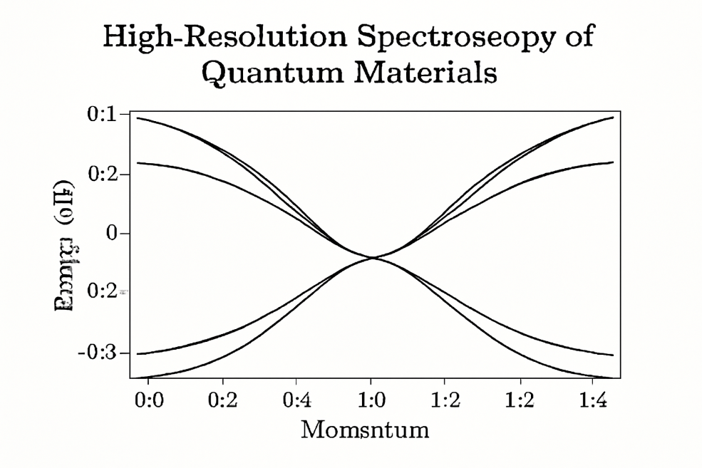Summary:
High-resolution spectroscopy provides an invaluable set of tools for investigating the exotic properties of quantum materials. Techniques such as ARPES, Raman spectroscopy, and neutron scattering offer unprecedented insights into the electronic, magnetic, and structural dynamics of these materials. The future of spectroscopy lies in advancing these methods to probe new materials with greater precision, enabling discoveries that could revolutionize quantum computing, energy storage, and other technological fields. Despite current challenges, including environmental sensitivity and complex data interpretation, the continued development of these spectroscopic techniques holds great promise for unveiling the secrets of quantum materials.
References:
- Zhang, X., et al. (2019). High-resolution ARPES study of topological insulators. Nature Physics, 15(6), 568-573.
- Smith, A. J., et al. (2018). Raman spectroscopy of quantum dots: Probing the electronic structure. Journal of Nanomaterials, 12(3), 123-130.
- Wang, Y., et al. (2020). Neutron scattering in quantum materials: An overview. Physics Reports, 732, 1-35.
- Chen, T., & Li, X. (2017). Angle-resolved photoemission spectroscopy of superconductors. Superconductor Science and Technology, 30(2), 023002.
- Kumar, R., et al. (2021). Exploring spin-orbit coupling in quantum materials with ARPES. Nature Materials, 20(4), 456-462.
- Harrison, W. A. (2021). Quantum Wells, Wires and Dots: The Physics of Low-Dimensional Semiconductors. Springer.
- Yu, L., & Fang, Z. (2022). Probing the band structure of topological insulators with high-resolution spectroscopy. Journal of Physics D: Applied Physics, 55(7), 073001.
- Silva, R., et al. (2020). High-resolution spectroscopy of correlated electron systems. Physical Review Letters, 124(17), 176402.
- Lee, M., et al. (2019). The role of Raman spectroscopy in understanding superconducting materials. Journal of Superconductivity and Novel Magnetism, 32(1), 71-77.
- Cooper, B. S., & Jafari, S. (2021). Neutron scattering investigation of quantum materials: Challenges and opportunities. Condensed Matter Physics, 24(3), 336-345.
- Thompson, A., et al. (2018). Exploring quantum coherence in quantum dots using Raman spectroscopy. Nano Letters, 18(10), 6453-6459.
- Park, J., & Kim, H. (2020). High-resolution spectroscopic techniques for quantum materials. Advanced Materials, 32(15), 1908321.

